1. Zopakuj si písanie písaného a tlačeného písmena O, o.
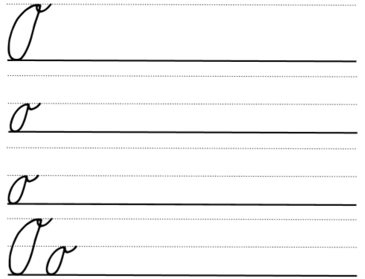
Každé písmeno najprv prečítaj: veľké/malé tlačené/písané písmeno o.
2. Spájaj písmená do slov. Prepíš slová písaným písmom:

On..................................................................................................................................................................................................
Os.................................................................................................................................................................................................
No.................................................................................................................................................................................................
no.................................................................................................................................................................................................
on.................................................................................................................................................................................................
Áno........................................................................................................................................................................................
iná.................................................................................................................................................................................................
ona.............................................................................................................................................................................................
Ona......................................................................................................................................................................................

